EXPERIMENT – 10

Name: Rohit Bhardwaj

SAP ID: 500082993

Batch: B2

**TITLE: Collections**

1. **Write a program for the following**

* Read all elements from ArrayList by using Iterator.
* Create duplicate object of an ArrayList instance.
* Reverse ArrayList content.

**CODE**

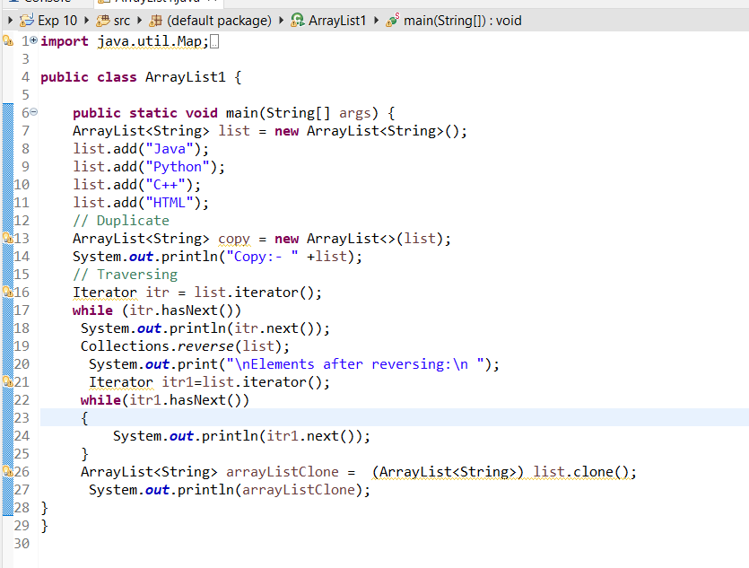

**OUTPUT**

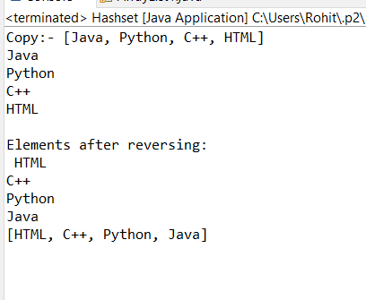

1. **Write a program for the following HashMap**

* find whether specified key exists or not.
* find whether specified value exists or not
* get all keys from the given HashMap
* get all key-value pair as Entry objects

**CODE**

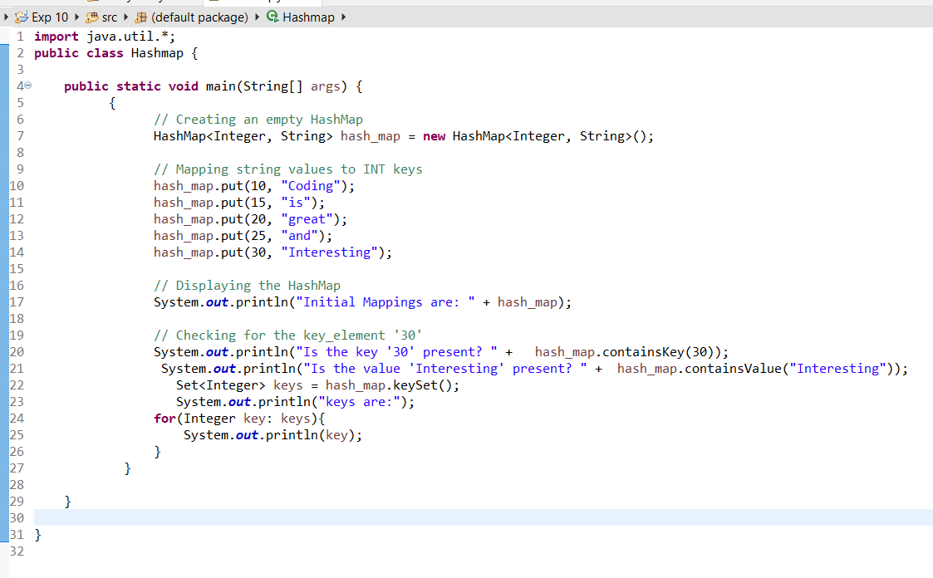

**OUTPUT**

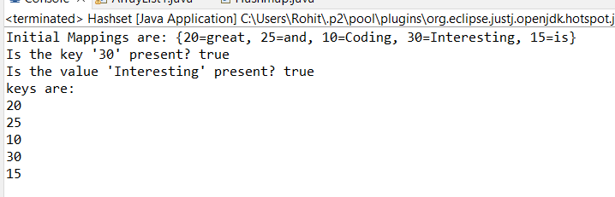

1. **Write a program for the following HashSet**

* copy another collection object to HashSet object.
* delete all entries at one call from HashSet
* search user defined objects from HashSet

**CODE**

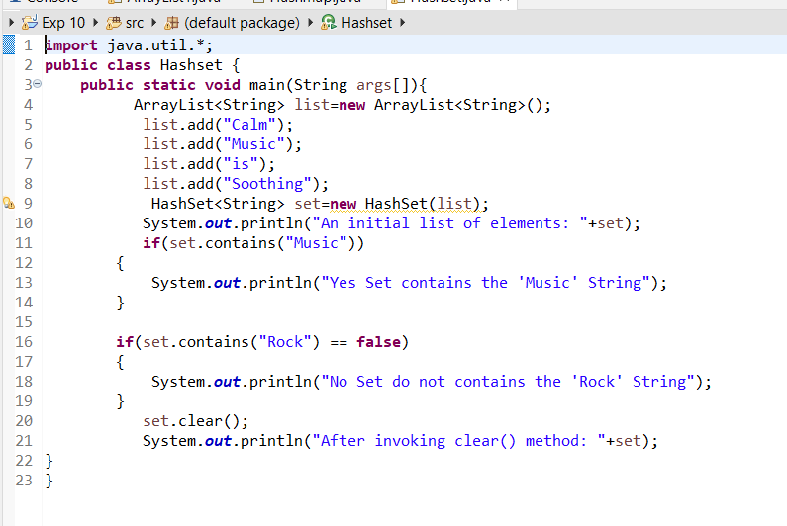

**OUTPUT**

